Normet UK Ltd
Unit 5 Wheler Road
Seven Stars Industrial Estate
Coventry CV3 4LJ
United Kingdom
Email: ross.dimmock@normet.com
www.normet.com
www.tam.uk.com

02 November 2012

Press Release

Even stronger underground! Sergio Matias joins Normet UK
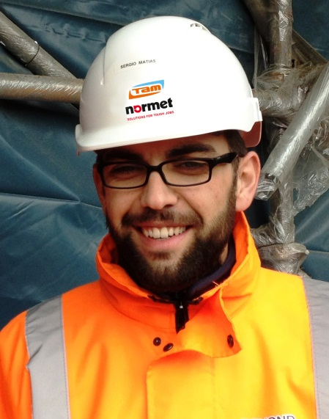
From October 2012 Sergio Matias has joined the successfully growing Normet UK team as the Technical Manager for underground construction and mining. Sergio is part of a 10 man team dedicated to supporting tunnels contractors, mining companies and designers, making it the strongest team in the business required to support the increasing number of underground projects.
Sergio is a Civil Engineer and originates from Portugal. He has had numerous roles in his relatively short career essentially focused on high performance concrete production in such places as Angola, Portugal and now the UK. His recent role developing high performance sprayed concrete on Crossrail as a contractor has further broadened his technical capability, and Sergio will undoubtedly prove to be a great asset to the Normet team.
Sergio’s professional passion is to efficiently turn sand, cement and water into incredible civil engineering structures, and we are hoping he will add a few construction chemicals too to make them even better! Normet actively support the technical development of underground processes through active participation on international and national tunnelling and mining forums. Sergio is supporting the industry as a member of the new BTS SCL Best Practice Group and actively contributes to the group reviewing applicable testing methods and materials for successful sprayed concrete tunnel linings.

About Normet
Normet is a fast growing Finnish technology company with global operations. It provides advanced solutions for selected customer processes in underground mining and tunnelling environments. The Normet Group develops, manufactures and markets machines, services, and construction chemicals for underground processes such as robotized concrete spraying, highly mechanized explosive charging and scaling, lifting and Installation, and logistics.
One of Normet's key missions is to improve the health and safety of the underground workers through the mechanization and automating the most demanding and dangerous stages of underground excavation, and improving the efficiency of its customers' processes by saving time and money.
Normet`s offering includes a comprehensive range of life time care (LTC) services for the equipment and the processes they are used for.
Today Normet is the global market leader in its market segment. Normet has its own sales and service companies in 5 continents, 22 countries and 36 locations. The Group´s net sales in 2011 were EUR 170 million. Normet currently employs close to 900 business professionals.

About Normet UK
Normet fully acquired TAM International Ltd in 2012 and formed Normet UK Ltd. Normet UK employs 18 business professions, all dedicated to the underground construction and mining sector in the UK and Ireland. From the Coventry Headquarters, Normet UK produces and supplies all construction chemicals for sprayed concrete and TBM tunnelling, ground engineering and solutions for extending the service life of underground structures.
Normet UK’s key projects in 2012 include the sprayed concrete package for Crossrail C410, TBM backfill grout for C300, sprayed concrete and equipment for Tara Mine in Ireland, London and Glasgow Underground rehabilitation and the M6 motorway repair.

For more information contact:
Ross Dimmock
Managing Director
UK & Ireland

Normet UK Ltd
Unit 5 Wheler Road
Seven Stars Industrial Estate
Coventry CV3 4LJ
Mob: +44 (0) 780 8765 923
Tel: +44 (0) 333 240 9966
Email: ross.dimmock@normet.com

